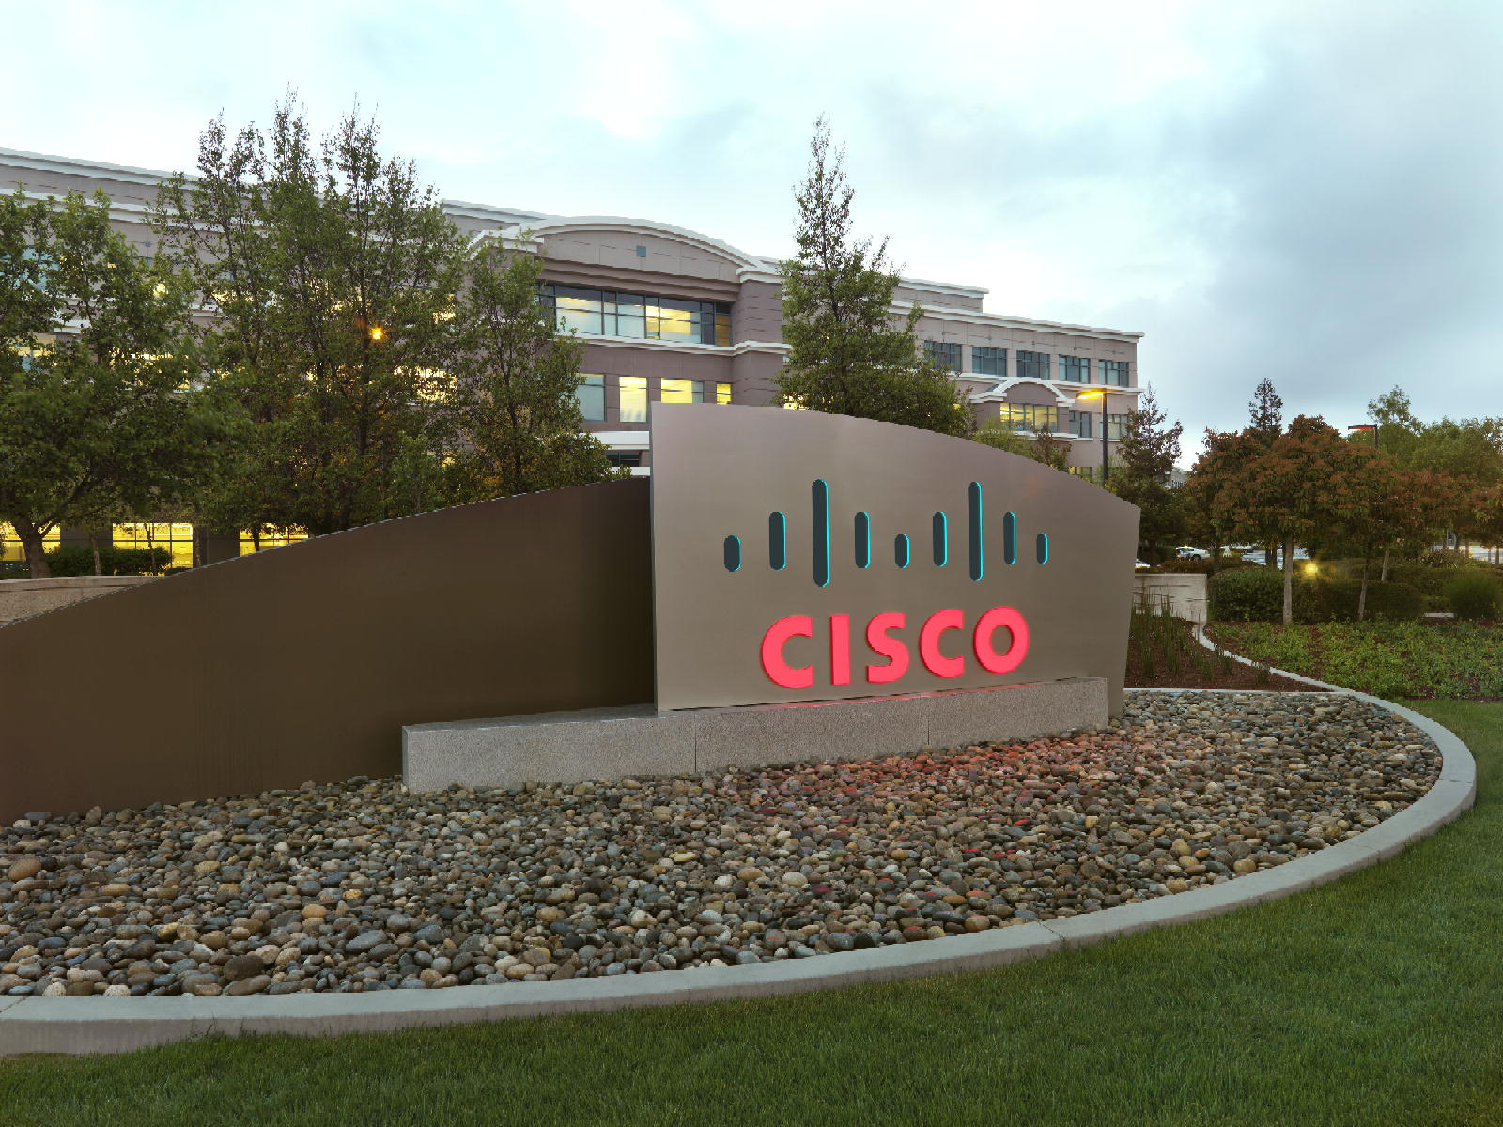

Advanced Service Assets

“PDTool” Promotion and Deployment Tool

Regression Automated Test Framework
Data Virtualization Business Unit Advanced Services
June 2015

TABLE OF CONTENTS
INTRODUCTION 4
License 4
Purpose 4
Audience 4
Platform Support 4
PDTool Regression Automated Test Framework 5
Introduction 5
1. Functional Test (Generate and Execute): 5
2. Migration or Regresion Test (Data set and Log Comparison): 5
3. Performance Test (Log Comparison): 5
4. Security Test (Users and Privileges): 5
Folder Structure 5
The Scripts 6
Getting Started 6
Script Framework – Template Generation Scripts 8
Script Framework – Baseline Execution Scripts 9
Script Framework – “Test Type” Execution Scripts 11
Script Framework – Documentation 12
Script Framework – Log 12
Script Framework – Plans 13
Script Framework – Modules 13
Script Framework – SQL Queries 14
Script Framework – Output 14
Security Test Configuration 17
Installation and COnfiguration 24
Introduction 24
Planning 24
Installation and Configuration Setup 24
Sample Installation 26
Changing The PDTool Password 29
Introduction 29
PDTool 6.2 29
PDTool 7.0 29
conclusion 31
Concluding Remarks 31
How you can help! 31

Document Control

Version History
Version | Date | Author | Description
1.0 | 06/11/2015 | Mike Tinius | Initial revision for Regression Module Automated Test Framework

Related Documents
Document | Date | Author
Cisco AS Promotion and Deployment Tool Module - Regression | Cisco AS Promotion and Deployment Tool Module - Regression.pdf | Mike Tinius

Data Virtualization Business Unit (DVBU) Products Referenced
DVBU Product Name | Version
Composite Information Server | 6.2, 7.0
INTRODUCTION

License
(c) 2015 Cisco and/or its affiliates. All rights reserved.
This software is released under the Eclipse Public License. The details can be found in the file LICENSE. Any dependent libraries supplied by third parties are provided under their own open source licenses as described in their own LICENSE files, generally named .LICENSE.txt. The libraries supplied by Cisco as part of the Composite Information Server/Cisco Data Virtualization Server, particularly csadmin-XXXX.jar, csarchive-XXXX.jar, csbase-XXXX.jar, csclient-XXXX.jar, cscommon-XXXX.jar, csext-XXXX.jar, csjdbc-XXXX.jar, csserverutil-XXXX.jar, csserver-XXXX.jar, cswebapi-XXXX.jar, and customproc-XXXX.jar (where -XXXX is an optional version number) are provided as a convenience, but are covered under the licensing for the Composite Information Server/Cisco Data Virtualization Server. They cannot be used in any way except through a valid license for that product.
This software is released AS-IS!. Support for this software is not covered by standard maintenance agreements with Cisco. Any support for this software by Cisco would be covered by paid consulting agreements, and would be billable work.

Purpose
The purpose of the Regression Module “Regression Automated Test Framework” is to make it easier to utilize the PDTool Regression Module testing capability by generating the necessary PDTool plans and module files. The focus of these scripts is on regression testing on a single CIS platform and performing comparisons from one CIS code release to another.

Audience
This document is intended to provide guidance for the following users:
- Architects
- Developers
- QA Testers.

Platform Support
The Automated Test Framework is only supported on Windows.

PDTool Regression Automated Test Framework

Introduction
Regression testing is the act of testing a CIS code release and comparing that release with the previous release.
This framework provides a way to accomplish automated testing for Cisco Information Server 6.2 and 7.0 published resources including Views, Procedures and Web Services. This framework is based on the Cisco Advanced Services PDTool Deployment and Regression Testing tool. Documentation for the PDTool can be found within the PDTool installation “docs” directory and the file “Cisco AS Promotion and Deployment Tool Module - Regression.pdf”. There are several types of tests that can be performed with this framework including:

Functional Test (Generate and Execute):
This represents the current functionality which tests whether the published view, procedure or web service is functional or not. All that is necessary for this test is to execute a SELECT COUNT(1) cnt FROM <view> or SELECT COUNT(*) cnt FROM <procedure> to prove that the view or procedure is functional. This type of test is also known as a “smoke” test.

Migration or Regresion Test (Data set and Log Comparison):
The PD Tool Regression Module will help Administrators during Migrations from one version of CIS to another by performing the regression testing on the new version of CIS or by performing a Regression test against two releases of a project. These tests are functionally the same. The caveat to this test is that the result sets used for comparison must be derived from the same data sources. Any changes in data values may result in differences in result set and thus comparisons will not be equal.

Performance Test (Log Comparison):
The PD Tool Regression Module can be used by QA to perform performance tests against views, procedures and web services. The two logs generated during the query execution are compared to determine success or failure based on a duration comparison.

Security Test (Users and Privileges):
The PD Tool Regression Module can be used by QA to perform security tests. The security test correlates users with functional test queries. It provides a way to test the expected outcome for a given user and query to determine if the test results in a PASS or FAIL. All tests are executed and an overall result of PASS or FAIL is awarded. The security test can be configured to throw an exception upon an overall status of FAIL.

Folder Structure
The following screenshot shows the “Regression Automated Test Framework” folder structure. This testing framework provides a wrapper around the Cisco Advanced Services PDTool capability. It allows for an automation of a CIS Business Line/Business Area as defined by the user.
It provides a central place for documentation, logs, reports, output and PDTool scripts. This is a cookie-cutter (repeatable) approach to testing. As such there is a templates folder and a script that is used to generate the testing artifacts for a given Business Line/Business Area. The template scripts generate the “docs”, “modules”, and “plans” that PDTool uses. The “Regression Automated Test Framework” folder structure is as follows:
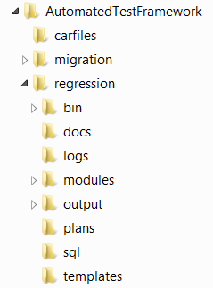
Image 2: Regression Automated Test Framework Folder Structure

The Scripts
The scripts in “/bin” provide the basis for the automation. The scripts will be defined in a later section.
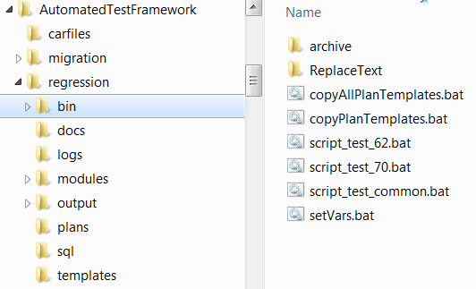
Image 3: Regression Automated Test Framework Scripts

Getting Started
This section discusses how to get started with the basics of testing.
Testing CIS Published Resources:
Requirements:
- For CIS 6.2, PDTool 6.2 is required to be installed.
- For CIS 7.0, PDTool 7.0.0 is required to be installed.
Planning
- It is important to plan ahead when using the “Regression Automated Test Framework”. The following section will help the test user prepare: Planning
Installation and Configuration Setup
- Some post-installation configuration is required to use the “Regression Automated Test Framework”. The following section provides the details: Installation and Configuration Setup
- Details for installing the sample can be found here: Sample Installation
Generate Test Scripts
- Determine the name to give to the set of published views that you want to test. Typically this is known as the “Business Line / Business Area / Subject Area”. The scripts will be based on this nomenclature. The name is required to be unique across all other names in use because it is used to generate the scrits.
- Use the script “copyPlanTemplates.bat” to generate the necessary PDTool plans and module files. More information can be found in this section of this document: Script Framework – Template Generation Scripts.
- Save a list of all of your names using “copyAllPlanTemplates.bat” so that you can regenerate all of plans and modules at once if required.
Determine which CIS environment “ENV” you are going to execute against such as:
- Example: DEV, UAT, PROD.
- These environments are defined by the CIS Administrator.
Determine which Business Line / Business Area you are testing.
- Open the generated documentation in /docs for your Business Line /Business Area.
- E.g. \docs\ documentation_MyProject1SubProj.txt
Determine which type of test you want to execute.
- Smoke Test Generation
- Smoke Test Execution
- Regression Test Execution
- Regression Test Comparison
- Performance Test Execution
- Performance Test Comparison
- Security Test Generation
- Security Test Execution
Refer to \docs\documentation_BusLineBusArea.txt or the example in this document.
Reference this document: Script Framework – “Test Type” Execution Scripts
Execute the test
Refer to the parameters for script execution. Set the RENAME_REL=false if you want a series of tests to go to the same release folder.
Reference this document: Script Framework – Baseline Execution Scripts
Example Scenario: Test 2: Execute Regression Test for UAT 6.2 and MyProject using TOP SQL queries and force the test output to go into the existing “626R1” release folder without renaming it.
script_test_62.bat UAT MyProject1SubProj_2Regression_exec.dp TOP false true

Script Framework – Template Generation Scripts
The scripts located in “/bin” provide the basis for generating the automation scripts from templates.
copyPlanTemplates.bat – The purpose of this batch file is to make it easy to copy a single plan template for doing regression testing. The premise of this script is to prepare all of the necessary PDTool plans, modules and docs for a given Business Line / Business Area for all of the various PDTool Regression Module tests including: Smoke, Regression, Performance and Security.
- copyPlanTemplates.bat [BusLineBusAreaSubjArea] [DATA_SOURCE_NAME] [RESOURCE_NAME] [false]
  - BusLineBusAreaSubjArea - The BusLineBusAreaSubjArea is the portion of the deployment plan file name that occurs prior to the mandatory test type descriptor.
    - Affix any prefix or postfix desired to BusLineBusAreaSubjArea such as prefix_BusLineBusAreaSubjArea_postfix
    - Test type descriptor: _1Smoke_gen.dp, _1Smoke_exec.dp, _2Regression_exec.dp, _2Regression_compare.dp, _3Performance_exec.dp, _3Performance_compare.dp, _4Security_gen.dp, _4Security_exec.dp
    - Example constructed Deployment plan: prefix_MyProject1_MySubject_post_3Performance_exec.dp
    - |___BusLineBusAreaSubjArea____|
    - |_____________Deployment Plan File Name____________|
  - DATA_SOURCE_NAME - This is published Composite data source to connect to for generating or executing queries.
  - RESOURCE_NAME - This may be CATALOG.SCHEMA.* or it may just be CATALOG.*. This is the filter based on Business Line and Business Area. The asterisk indicates a wildcard and is used to specify any views that are published in the location of the preceding resource name.
  - PROMPT_USER - when doing automated set PROMPT_USER=false so that it does not prompt the user to edit the Regression Module XML file.
- Example1: Test all views from all FooCat catalog schemas in the same framework
  - Create a the regression test framework for a new Business Line / Business Area called “Foo” with a published catalog called FooCat in the “MY DB” database. The catalog contains multiple schemas FooSch1 and FooSch2 and the user wants to be able to test all views from all schemas from the same test framework.
  - copyPlanTemplates.bat Foo “MY DB” FooCat.* true
- Example2: Test views from each FooCat catalog schema separately in different frameworks.
  - Create a the regression test framework for a new Business Line / Business Area called “Foo” with a published catalog called FooCat in the “MY DB” database. The catalog contains multiple schemas FooSch1 and FooSch2 and the user wants to be able to test the views for each schema independently of the other schema. To accomplish this we will setup two test frameworks
  - copyPlanTemplates.bat FooSch1 “MY DB” FooCat.FooSch1.* true
  - copyPlanTemplates.bat FooSch2 “MY DB” FooCat.FooSch2.* true
copyAllPlanTemplates.bat – The purpose of this batch file is to make it easy to copy “ALL” of the regression test Business Line / Business Areas at one time specified in the “copyAllPlanTemplates.bat” file. This batch file will overwrite existing deployment plans (/plans), module XML files (/modules) and docs files (/docs).

Script Framework – Baseline Execution Scripts
The scripts located in “/bin” provide the basis for executing PDTool standard scripts.
These scripts provide a wrapper around the actual PDTool scripts. They provide context for the environments [DEV, UAT, PROD]. They output the logs for each execution into /logs directory according to each type of test so that the log is retained across different types of tests.
Types of scripts
script_test_62.bat – Provides an instance of execution for PDTool6.2. Requires its own installation of PDTool6.2. This script can only be run from a single command line window at one time. It cannot be run in parallel from two different command line windows.
script_test_70.bat – Provides an instance of execution for PDTool7.0.0. Requires its own installation of PDTool7.0.0. This script can only be run from a single command line window at one time. It cannot be run in parallel from two different command line windows.
Command Line:
script_test_NN.bat ENV_TYPE DEPLOYMENT_PLAN [CUSTOM] [RENAME_REL] [PAUSE]
Parameters:
ENV_TYPE – Example: [DEV|UAT|PROD]
- The valid values are defined as a result of the variable: VALID_ENV_CONFIG_PAIRS
DEPLOYMENT_PLAN - The name of the deployment plan such as:
- BusLineBusArea_1Smoke_gen.dp
- BusLineBusArea_1Smoke_exec.dp
- BusLineBusArea_2Regression_exec.dp
- BusLineBusArea_2Regression_compare.dp
- BusLineBusArea_3Performance_exec.dp
- BusLineBusArea_3Performance_compare.dp
- BusLineBusArea_4Security_gen.dp
- BusLineBusArea_4Security_exec.dp
CUSTOM – [optional] variable
- blank or "" – [default]. Generate or execute using SQL SELECT COUNT(1) cnt or SELECT COUNT(*) cnt.
- TOP - If the word TOP is provided then generate or execute using the SELECT TOP 1 * command. Top is a special type of CUSTOM.
- CUSTOM value - If any other word is used then execute the SQL file using this pattern and the value of the CUSTOM variable:
Example: Developer creates a custom SQL file where the custom name = MyQueries
Template: Example:
\sql\BusLineBusArea_RegressionTest_SQL_%CUSTOM%.txt = \sql\MyProject_RegressionTest_SQL_MyQueries.txt
\sql\BusLineBusArea_PerfTest_SQL_%CUSTOM%.txt = \sql\MyProject_PerfTest_SQL_MyQueries.txt

RENAME_REL – [optional] variable. Default=true
- blank or "" or true - force a rename of the release output folders upon each execution of this script.
- false - disable the rename function and allow the results to go to the existing RELEASE_FOLDER1 directory.
Example. This can be useful when executing a series of tests for the same release such as the following: Smoke Test, Regression Test, Performance Test and Security Test.
Note: This script will automatically ignore renaming the output folder for the following and thus the RENAME_REL does not have to be set.
Generating Smoke Test, Compare Regression Test, Compare Performance Test and Generate Security Test.
PAUSE – [optional] variable. Default=true
- blank or "" or true - pause during script execution.
- false - no pause during script execution.
Exiting a script
How to exit a script – Use Control-C to exit a script. Type Y and return to exit. If the script is in the middle of executing and you press Control-C the prompt will not be visible. Type “Y” and press the return key to exit the script.

Script Framework – “Test Type” Execution Scripts
The scripts provide the basis for executing PDTool standard scripts.
Script framework “test type” single execution scripts
The section provides information on how to run a single specific type of test. The optional parameters at the end indicate whether to use the SQL queries containing CUSTOM queries ot not. The keyword TOP is classified as a special kind of CUSTOM query that allows the user to execute queries such as “SELECT TOP 1 * “. The user may wish to specify other CUSTOM keywords that relate to SQL query files where the user has populated the file with their own queries. If no CUSTOM option is provided, then the “SELECT COUNT(1)” queries are used.
Additionally there is an option for RENAME_REL and PAUSE set to true or false following CUSTOM. RENAME_REL informs the script to rename the release folder or not. If RENAME_REL=false then the user can force the output for a series of tests to be placed into the RELEASE_FOLDER1 which is defined within the script execution batch files [script_test_62.bat and script_test_70.bat].
PAUSE informs the scripts to pause before execution so that the user can see what variables are set before continuing.
Test 1: Generate Smoke Test SQL for ENV
script_test_62.bat ENV BusLineBusArea_1Smoke_gen.dp "" "" [PAUSE]
script_test_70.bat ENV BusLineBusArea_1Smoke_gen.dp "" "" [PAUSE]
Test 1: Execute Smoke Test for ENV
script_test_62.bat ENV BusLineBusArea_1Smoke_exec.dp "" [RENAME_REL] [PAUSE]
script_test_70.bat ENV BusLineBusArea_1Smoke_exec.dp "" [RENAME_REL] [PAUSE]
Test 2: Execute Regression Test for ENV
script_test_62.bat ENV BusLineBusArea_2Regression_exec.dp [CUSTOM] [RENAME_REL] [PAUSE]
script_test_70.bat ENV BusLineBusArea_2Regression_exec.dp [CUSTOM] [RENAME_REL] [PAUSE]
Test 2: Execute Regression Test Compare for ENV - Compare files and logs for difference
script_test_62.bat ENV BusLineBusArea_2Regression_compare.dp [CUSTOM] "" [PAUSE]
script_test_70.bat ENV BusLineBusArea_2Regression_compare.dp [CUSTOM] "" [PAUSE]
Test 3: Execute Performance Test for ENV
script_test_62.bat ENV BusLineBusArea_3Performance_exec.dp [CUSTOM] [RENAME_REL] [PAUSE]
script_test_70.bat ENV BusLineBusArea_3Performance_exec.dp [CUSTOM] [RENAME_REL] [PAUSE]
Test 3: Execute Performance Test Compare for ENV - Compare logs for difference
script_test_62.bat ENV BusLineBusArea_3Performance_compare.dp [CUSTOM] "" [PAUSE]
script_test_70.bat ENV BusLineBusArea_3Performance_compare.dp [CUSTOM] "" [PAUSE]
Test 4: Generate Security Test for ENV
script_test_62.bat ENV BusLineBusArea_4Security_gen.dp “” "" [PAUSE]
script_test_70.bat ENV BusLineBusArea_4Security_gen.dp “” "" [PAUSE]
Test 4: Execute Security Test for ENV
script_test_62.bat ENV BusLineBusArea_4Security_exec.dp “” [RENAME_REL] [PAUSE]
script_test_70.bat ENV BusLineBusArea_4Security_exec.dp “” [RENAME_REL] [PAUSE]
EXAMPLE 1:
Scenario: Test 2: Execute Regression Test for UAT 6.2 and MyProject using TOP SQL queries and force the test output to go into the existing “626R1” release folder without renaming it.
script_test_62.bat UAT MyProject1SubProj_2Regression_exec.dp TOP false true
EXAMPLE 2:
Scenario: Test 2: Execute Regression Test for UAT 6.2 and MyProject using cusom SQL queries and force the test output to go into a new “626R1” release folder.
script_test_62.bat UAT MyProject1SubProj_2Regression_exec.dp MyCustom “”

Script Framework – Documentation
The “/docs” folder contains all of the Business Line / Business Area generated documentation for all of the tests. It was prepared by the “copyPlanTemplates.bat” script. The file “Regression Test Summary.xlsx” provides a place to tally test results.
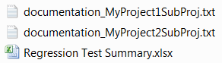
Image 4: Documentation for Business Line / Business Area

Script Framework – Log
The “/logs” folder contains output for a given CIS version, environment, Business Line/Area, Test Type and SQL test type. In the screenshot below each part of the log file path is described. This allows for a high degree of naming so that the logs can be preserved across different test types. However, if the exact same test is run again then it will overwrite an existing log of the same name.

PDTool Config Environment Business Line/Bus Area Test Type SQL Type
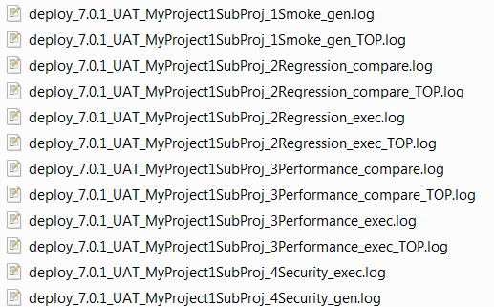
Image 5: Log Naming Conventions

Script Framework – Plans
The “/plans” folder contains all of the deployment plan files for all of the tests. It was prepared by the copyAllPlanTemplates.bat script.
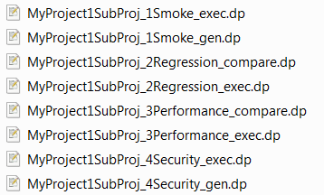
Image 6: Deployment Plan Files

Script Framework – Modules
The “/modules” folder contains all of the deployment module files for all of the tests. It was prepared by the copyAllPlanTemplates.bat script.
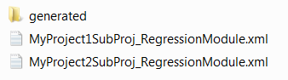
Image 7: Deployment Module Files

Script Framework – SQL Queries
The “/sql” folder contains all of the SQL query files for all of the tests. The Smoke test files were generated. The Regression and Performance files were prepared manually so that the tester can control what they want to test. Custom queries can be provided or the tester can copy and paste from the Smoke Test query set. For custom files add a custom name following “SQL_” as shown below in a file name such as “MyProject1SubProj_RegressionTest_SQL_MyCustom.txt”. Not “_TOP” is a special kind of custom file that contains “select TOP 1 *” queries.
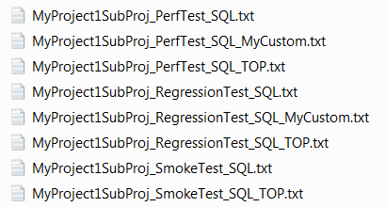
Image 8: SQL Query Files

Script Framework – Output
The “/output” folder contains a folder for each Business Line / Business Area. That subfolder contains the result logs for each test type as well as subfolders for the regression tests which contain the data files for each query.
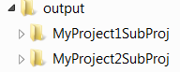
Image 9: Output Folders
For example, let’s use MyProject1SubProj as a guide. The screen shot below shows several release folders for both 6.2 and 7.0. The folder “701R1” is the RELEASE_FOLDER1 and “701R2” is RELEASE_FOLDER2 as specified in the script execution batch files. The folders with “.0001” and so on represent the archive of the “701R2” folders:
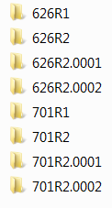
Image 10: Contents of a Business Line / Business Area Folder
The screen shot below shows an example of the content of a release folder such as “701R1” or “701R2”. The release folder contains one or more logs and sub-folders where the query output is stored for each test type segregated by environment type. All log files are prefixed with the environment type so that any given release can be tracked across multiple CIS environments.
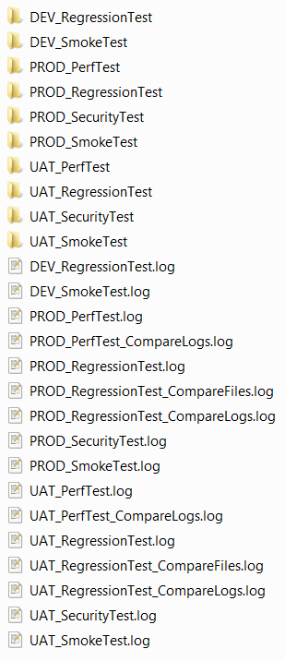
Image 11: Contents a release folder such as “701R1” or “701R2”
Description of the various log files
ENV_PerfTest.log or ENV_PerfTestTOP.log – This is the performance test log for a given release [701R1] as a result of executing regular queries or TOP-n queries. It logs the duration of execution for each thread along with the query executed over a defined period of time. It logs any errors that occur.
ENV_PerfTest_CompareLogs.log or ENV_PerfTestTOP_CompareLogs.log – Provides a comparison between two different releases [701R1 and 701R2] for a given CIS version of performance logs for regular or TOP-n queries to determine [for the same query] the following:
Duration matched (same)
Duration improved (performance improved)
Duration was within acceptable range (user defined)
Duration exceeded range
ENV_RegressionTest.log or ENV_RegressionTestTOP.log – This is the regression test log for a given release [701R1] as a result of executing regular queries or TOP-n queries. It only executes the query once. It logs duration of execution for each query along with the query executed. It logs any errors that occur.
ENV_RegressionTest_CompareFiles.log or ENV_RegressionTestTOP_CompareFiles.log – Provides a comparison between two different releases [701R1 and 701R2] for a given CIS version of data files for regular or TOP-n queries to determine [for the same query] whether the files are an exact match or not. If the row-by-row checksums match then the query is marked with “SUCCESS” otherwise it is marked with “FAILURE”. The key to this test is to test against the same data set for both releases [701R1 and 701R2].
ENV_RegressionTest_CompareLogs.log or ENV_RegressionTestTOP_CompareLogs.log – Provides a comparison between two different releases [701R1 and 701R2] for a given CIS version of regression logs for regular or TOP-n queries to determine [for the same query] the following:
Duration matched (same)
Duration improved (performance improved)
Duration was within acceptable range (user defined)
Duration exceeded range
Regression Test Data Files:
The screen shot below demonstrates how a data file is created. A subfolder is created to represent the type of test and version such as “701R1\ENV_RegressionTest_TOP” so that tests can be run against either 6.2 or 7.0. Underneath that folder is another with the same name as the Composite Data Source being tested such as “MY DB”. Underneath “MY DB” are the data files for each query and named according to Catalog.Schema.Table name.
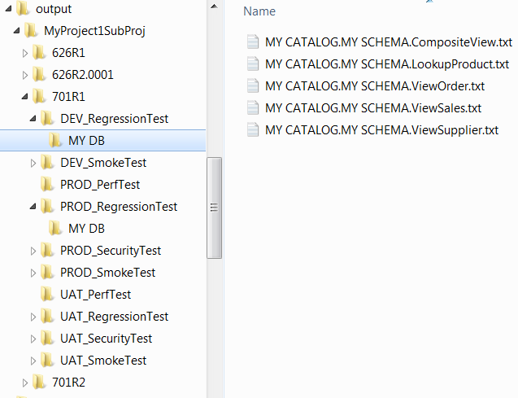
Image 12: Regression Test Data Files
Performance Test Data Files
Even though a subfolder is created for performance test such as “701R1\PerfTest_TOP” there are no data files created.

Security Test Configuration
The security test correlates users with functional test queries and provides a way to test the expected outcome for a given user/query combination to determine if the test results in a PASS or FAIL. The security test does not use a separate SQL input file like the other tests use. Instead all of the users, queries and correlated tests are defined within the Regression Module XML file. Since this is originally generated from a template, it will not have the correct values to start out with. There is a process involved to generate the queries and then configure them to meet the test requirements. Let’s consider this high-level overview of the process involved to configure a security test:
- Configure the list of users in the regression module XML file that was derived from the template “BusLineBusAreaSubjArea_RegressionModule.xml”.
- Generate the security queries for the desired Business Line / Area / Subject Area.
- Copy generated security queries into the regression module XML file
- Edit expected results and assign the appropriate PASS/FAIL response.
Scenario: The development and/or QA team wants to validate that the privileges are set correctly on the various folder structures. When it comes to security, the following are guidelines or best practices:
- There are representative test resources in each of the folders to be tested.
- The development team has setup groups and a corresponding test user in each of the groups.
- Privileges are assigned to groups which are applied to folders recursively.
Here is a high-level summary of the steps for the “Security Test Process”:
Note: Refer to the PDTool documentation “Cisco AS Promotion and Deployment Tool Module - Regression.pdf” found in the PDTool/docs directory. Refer to the section titled “4. Security Test Process:” for the details.
- Step 1 – Regression Module XML for generating the regression security XML file.
- Step 2 – Deployment plan for generating the regression security XML file.
- Step 3 – Configure user list.
- Step 4 – Execute the Regression Security Generation plan
- Step 5 – Copy generated XML
- Step 6 – Regression Module XML for executing a Security test
- Step 7 – Deployment plan for “Executing the security test”
- Step 8 – Execute the Security Test plan.
- Step 9 – Review the results of the output log file.
Security Test Details
Step 1 – [NO ACTION REQUIRED] Regression Module XML was generated for a given project (Business Line / Area / Subject Area).

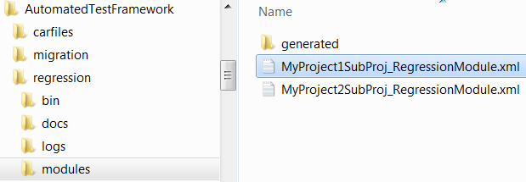
Image 13: Regression Module XML generated files

Step 2 – [NO ACTION REQUIRED] Deployment plan for “Generating the security XML” was generated for a given project (Business Line / Area / Subject Area).

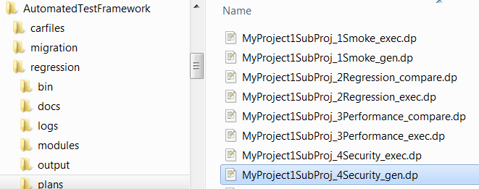
Image 14: Deployment plan generated files

Example deployment plan file entry for MyProject1SubProj_4Security_gen.dp:
PASS TRUE ExecuteAction generateRegressionSecurityXML $SERVERID Test4.1_$SCRIPT_CIS_VERSION "$REGRESSION_TEST_MODULES/%BusLineBusAreaSubjArea%_RegressionModule.xml" "$MODULE_HOME/servers.xml"
Step 3 – Configure user list
- Edit the Regression Module XML.
- Add a list of users that you want to use for testing security. These can be composite users or ldap users. Provide the user name, password and domain. Passwords may be encrypted after this part of the exercise is complete.
- There are two separate XML identifiers for CIS 6.2 and CIS 7.0. Configure one or both sections depending on which version of CIS is being tested.

<regressionTest>
<id>Test4.1_6.2</id> OR <id>Test4.1_7.0</id>
<securityGenerationOptions>
<!-- A security user default encrypted password. It will be encrypted when the ExecutePDTool.bat -encrypt ..\modules\RegressionModule.xml is executed.-->
<encryptedPassword>password</encryptedPassword>
<!-- Determines what CIS users to generate. Wildcards (*) may be used. -->
<userFilter>user1,user2</userFilter>
<!-- Provides a way of specifying what domain the userFilter should be applied to. -->
<domainFilter>composite</domainFilter>
</securityGenerationOptions>
</regressionTest>

Step 4 – Generate the Regression Security XML.
- Execute the Regression Security Generation plan which will execute the method “generateRegressionSecurityXML” to generate users, queries and security plan tests.
Example Execute Line:
script_test_70.bat UAT MyProject1SubProj_4Security_gen.dp "" "false"

Step 5 – Modify original Regression Module XML
- Copy the generated regression XML file section: “<regressionSecurity>” to the original Regression Module XML.
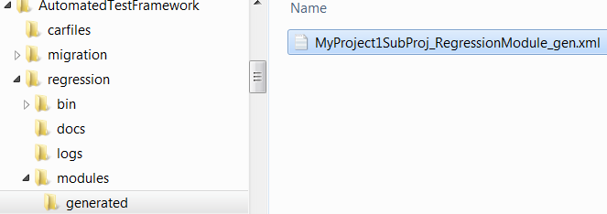
Image 15: Generated Regression Module XML
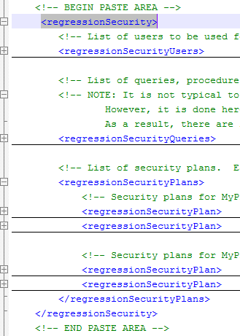
Image 16: Example of XML section that is to be copied and pasted

- Edit user list and supply correct password if necessary.
Example Regression Module XML (MyProject1SubProj_RegressionModule.xml):
<regressionSecurity>
<!-- List of users to be used for security testing. -->
<regressionSecurityUsers>
<!—Iteration of users for project: MyProject1SubProj -->
<regressionSecurityUser>
<id>rsu1</id>
<userName>user1</userName>
<encryptedPassword>password</encryptedPassword>
<domain>composite</domain>
</regressionSecurityUser>
<regressionSecurityUser>
<id>rsu2</id>
<userName>user3</userName>
<encryptedPassword>password</encryptedPassword>
<domain>composite</domain>
</regressionSecurityUser>
</regressionSecurityUsers>
</regressionSecurity>
- Re-encrypt password if necessary
ExecutePDTool.bat -encrypt ..\AutomatedTestFramework\regression\modules\MyProject1SubProj_RegressionModule.xml

- Validate Regression Security Plan tests – Validate the expected outcome for each plan test to insure that it is the correct outcome [PASS or FAIL]. This is a manual step performed by the developer, tester or administrator.
- Make a backup copy of the XML file in case you decide to regenerate the project files in the future.
Step 6 – [NO ACTION REQUIRED] Regression Module XML for “Executing the security test” was generated for a given project (Business Line / Area / Subject Area).
Image 17: Regression Module XML generated files

Step 7 – [NO ACTION REQUIRED] Deployment plan for “Executing the regression security test” was generated for a given project (Business Line / Area / Subject Area).
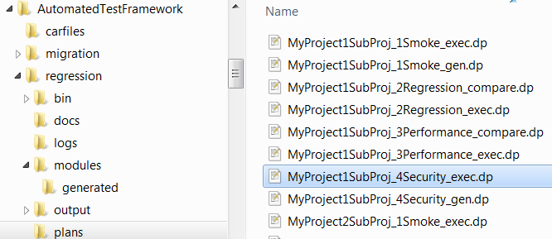
Image 18: Deployment Plan for Security Execution
- Example deployment plan file entry for MyProject1SubProj_4Security_exec.dp:
PASS TRUE ExecuteAction executeSecurityTest $SERVERID Test4.1_$SCRIPT_CIS_VERSION "$REGRESSION_TEST_MODULES/%BusLineBusAreaSubjArea%_RegressionModule.xml" "$MODULE_HOME/servers.xml"

Step 8 – Execute the Regression Security Test plan.
- Executing the regression test is accomplished by running the Automated Test Framework scripts.
- This regression security test will use the queries generated in the regression security XML and execute them against CIS. It will log the results into a summary execution file in the file system. It will use several filters that you previously set up in the regression XML file. For example, you can turn on and off execution of the three categories, queries, procedures and web services. You can also filter on which datasources you execute tests for. The input file may contain a broad list of datasources and queries but you don’t have to run all the tests.
Example Execute Line:
script_test_70.bat UAT MyProject1SubProj_4Security_exec.dp "" "false"

Step 9 – Review the results of the output file.
The results of the security test are saved the Automated Test Framework output folder under the project name and release sub-folders. The actual log file is called SecurityTest.log.
The following screen shot shows the location of the log file.

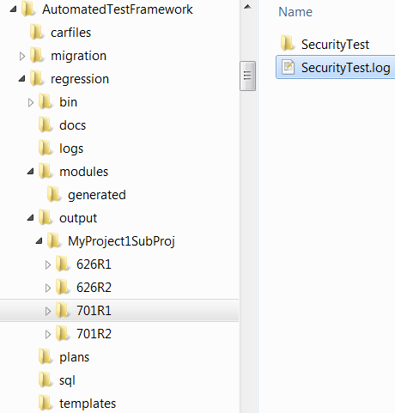
Image 19: Security Test Log Output Location – SecurityTest.log
The following screen shot shows the content of the SecurityTest.log file:
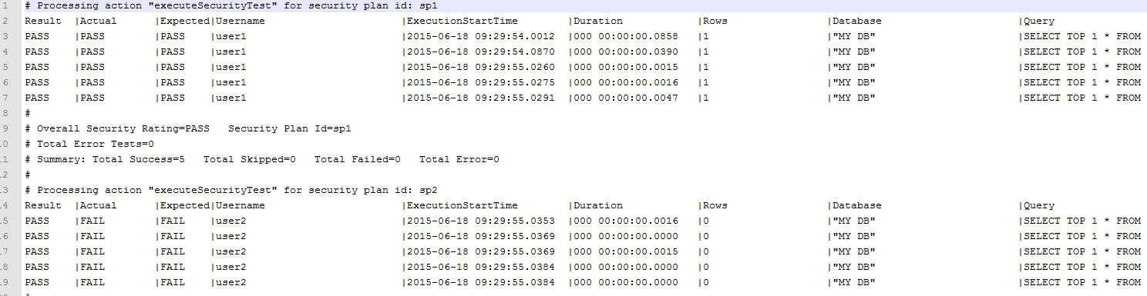
Image 20: Security Test Log Output

Installation and COnfiguration

Introduction
This section describes how to install and configure the “Regression Automated Test Framework”.

Planning
The section helps the test user to plan for how they want to use the testing framework.
Planning worksheet:
- Identify Published Resources to test: ______________________
  - Example published data source, catalogs and schemas
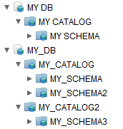
- Assign a name to the published resources: ______________________
  - Known as the Business Line or Business Area or Subject Area
- Determine the CIS environment names: ______________________
  - Example: DEV, UAT PROD
- Determine the PDTool config file mappings: ______________________
  - This is how a PDTool configuration property file maps to a given CIS environment.
  - Example:
    - ENV PDTool Configuration Property File Name
    - DEV = deploy_7.0_DEV.properties
    - UAT = deploy_7.0_UAT.properties
    - PROD = deploy_7.0_PROD.properties
- PDTool 6.2 directory location: ______________________
- PDTool 7.0 directory location: ______________________

Installation and Configuration Setup
The section provides the necessary steps for setting up the batch scripts used for testing.
Edit/Configure the setVars.bat batch file:
- Location: \AutomatedTestFramework\regression\bin\setVars.bat
REM # Set environment variables for PDTool 6.2
REM # Set the location of PDTool 6.2
set PDTOOL_INSTALL_HOME_6=C:\CompositeSoftware\PDTool_Test\PDTool6.2
REM List of valid Environments~Config property file name pairs. Comma separated no space and no double quotes. Tilde separates pairs: ENV~ConfigFileName. These are the property file names configured in the PDTool6.2\resources\config folder minus the .properties extension.
set VALID_ENV_CONFIG_PAIRS_6=DEV~deploy_6.2_DEV,UAT~deploy_6.2_UAT,PROD~deploy_6.2_PROD
REM Set the release folders to indicate which version is being tested
REM Release folder 1 is designated as the CIS instance current folder. R1 designates it is a release 1 primary, current folder.
REM Release folder 2 is designated as the CIS instance previous folder. R2 designates it is a release 2 secondary, previous folder.
set RELEASE_FOLDER1_6=626R1
set RELEASE_FOLDER2_6=626R2
REM # Set environment variables for PDTool 7.0
REM Set the location of PDTool 7.0
set PDTOOL_INSTALL_HOME_7=C:\CompositeSoftware\PDTool_Test\PDTool7.0.0
REM List of valid Environments~Config property file name pairs. Comma separated no space and no double quotes. Tilde separates pairs: ENV~ConfigFileName. These are the property file names configured in the PDTool7.0.0\resources\config folder minus the .properties extension.
set VALID_ENV_CONFIG_PAIRS_7=DEV~deploy_7.0.1_DEV,UAT~deploy_7.0.1_UAT,PROD~deploy_7.0.1_PROD
REM Set the release folders to indicate which version is being tested.
REM Release folder 1 is designated as the CIS instance current folder. R1 designates it is a release 1 primary, current folder.
REM Release folder 2 is designated as the CIS instance previous folder. R2 designates it is a release 2 secondary, previous folder.
set RELEASE_FOLDER1_7=701R1
set RELEASE_FOLDER2_7=701R2
REM # Set environment variables for Automated Test Framework
REM Automated Test Framework Home. This folder may be independent of where PDTOOL_INSTALL_HOME is located.
set ATF_HOME= C:\CompositeSoftware\PDTool_Test\PDTool6.2\AutomatedTestFramework\regression
REM # Used by copyPlanTemplates.bat
REM # Set JAVA_HOME to JRE7
if not defined JAVA_HOME set JAVA_HOME=C:\Program Files\Java\jre7
REM # Used by copyPlanTemplates.bat
REM # Use one or the other or provide your own text editor path.
REM # If you have notepad++ it is a much better editor than notepad.
REM # Do not put double quotes around path. The script takes care of that.
set EDITOR=C:\Program Files (x86)\Notepad++\notepad++.exe
rem set EDITOR=%windir%\system32\notepad.exe
REM Script Main Activity
set SCRIPT_ACTIVITY=Execute Regression Test
REM Debug=Y or N. Default=N
set DEBUG=N

Sample Installation
The section provides the necessary steps for setting up the sample.
Create groups on the target server where the sample will be imported:
- Launch CIS Manager and login
  - For 6.2, select “Users → Group Management”
  - For 7.0, select “Security → Group Management”
  - Select “Add Group”
    - Group name: group1
    - Click OK
  - Select “Add Group”
    - Group name: group2
    - Click OK
Create users on the target server where the sample will be imported:
- Note: The users “user1” and “user2” use the password text “password” within the sample files. If you wish to change the password, then you will need to provide the same password in the sample files
  - \AutomatedTestFramework\regression\modules
    - \MyProject1SubProj_RegressionModule.xml
    - \MyProject2SubProj_RegressionModule.xml
  - Encrypting passwords in files:
ExecutePDTool.bat -encrypt ..\AutomatedTestFramework\regression\modules\MyProject1SubProj_RegressionModule.xml
ExecutePDTool.bat -encrypt ..\AutomatedTestFramework\regression\modules\MyProject2SubProj_RegressionModule.xml
- Launch CIS Manager and login
  - For 6.2, select “Users → User Management”
  - For 7.0, select “Security → User Management”
  - Select “Add Group”
    - User name: user1
    - New password: password
    - Confirm password: password
    - Click OK
  - Select “Add Group”
    - User name: user2
    - New password: password
    - Confirm password: password
    - Click OK
Associate users with groups on the target server where the sample will be imported:
- Launch CIS Manager and login
  - For 6.2, select “Users → User Management”
  - For 7.0, select “Security → User Management”
  - Check the box next to “user1” and click “Edit Group Membership”
    - Check the box for “group1”
    - Click OK
  - Check the box next to “user2” and click “Edit Group Membership”
    - Check the box for “group2”
    - Click OK
Import the sample CAR file:
- Launch CIS Studio 6.2 or 7.0
- Right click on “Desktop (user)” and select Import
- Browse to the location of \AutomatedTestFramework\carfiles
- Select MySampleDBs.car and click Open
- Click Import>
- Click Done
Verify Privileges:
- Launch CIS Studio 6.2 or 7.0
- Right-click on “/services/databases/MY DB” and select “Privileges”
- Select the middle radio button “Hide users and groups without explicit privileges” and click OK
- The privileges should be as follows:
- Right-click on “/services/databases/MY_DB” and select “Privileges”
- Select the middle radio button “Hide users and groups without explicit privileges” and click OK
- The privileges should be as follows:

Changing The PDTool Password

Introduction
This section describes how to change your PDTool password.

PDTool 6.2
- Locate the PDTool 6.2 folder
C:\Users\%USERNAME%\.compositesw\PDTool\PDTool6.2
- Edit the variables file – setMyPrePDToolVars.bat
  - Locate the variable CIS_PASSWORD
set CIS_PASSWORD=Encrypted:6ABCABC9F46BAA2
  - Modify the password by removing all text after the “=” including the “Encrypted:”
set CIS_PASSWORD=
  - Enter your new password.
  - Save and close the file
- Open a command line
  - Change directories to the following location
cd C:\Users\%USERNAME%\.compositesw\PDTool\PDTool6.2\bin
  - Execute the following command
ExecutePDTool.bat -encrypt ..\..\setMyPrePDToolVars.bat
- Edit the variables file – setMyPrePDToolVars.bat
- Locate the variable CIS_PASSWORD and determine if the password is now encrypted.

PDTool 7.0
- Locate the PDTool 7.0.0 folder
C:\Users\%USERNAME%\.compositesw\PDTool\PDTool7.0.0
- Edit the variables file – setMyPrePDToolVars.bat
- Locate the variable CIS_PASSWORD
set CIS_PASSWORD=Encrypted:6ABCABC9F46BAA2
- Modify the password by removing all text after the “=” including the “Encrypted:”
set CIS_PASSWORD=
- Enter your new password.
- Save and close the file
- Open a command line
- Change directories to the following location
cd C:\Users\%USERNAME%\.compositesw\PDTool\PDTool7.0.0\bin
- Execute the following command
ExecutePDTool.bat -encrypt ..\..\setMyPrePDToolVars.bat
- Edit the variables file – setMyPrePDToolVars.bat
- Locate the variable CIS_PASSWORD and determine if the password is now encrypted.

conclusion

Concluding Remarks
The AS Promotion and Deployment Tool is a set of pre-built modules intended to provide a turn-key experience for promoting CIS resources from one CIS instance to another. The user only requires system administration skills to operate and support. The code is transparent to operations engineers resulting in better supportability. It is easy for users to swap in different implementations of a module using the Spring framework and configuration files.

How you can help!

Build a module and donate the code back to Cisco Advanced Services for the advancement of the “AS Promotion and Deployment Tool”.
Printed in USA CXX-XXXXXX-XX 10/11

Printed in USA CXX-XXXXXX-XX 10/11
Printed in USA CXX-XXXXXX-XX 10/11

